## Goals/Business Requirements/Background

1. Recover forward logistics and other charges from seller in case of 3PL or Liquidation state of orders.
2. Likely recovery could have been Rs ~ 80 lacs in Oct’16 & Rs ~ 85 lacs in Nov’16.
3. At an overall level, we’ll able to save 2-3 Rs/unit on monthly basis given the savings of 80-85 lakhs.

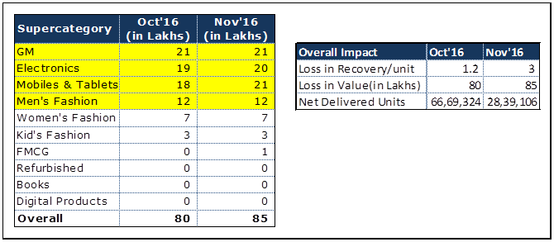

## Requirements

EPIC Link -

|  |  |  |  |
| --- | --- | --- | --- |
| **S.No** | **User Story Name** | **User story description** | **Notes (if any)** |
| 1 | [OPS] Add two new event types each for 3PL and Liquidation in Rate card reverse view  <https://tron.snapdeal.com/admin/ratecard/reverse/view> |  |  |
| 2 | [OPS] Allow via API such that ERAS system can fetch values and also fetch the order’s logistics and other cost heads for reversal |  |  |
| 2 | [ERAS] on receiving the event - 3PL or Liquidation , initiate a debit to seller basis the table in admin ratecard view as approved by business and finance. | New files to be created for a particular suborder state coming to any of these - 3PL/LQD |  |
| 3 | [ERP] Change on ERP side for this requirement. To be highlighted by Ravikant |  |  |

**ERAS side changes files:**

**ERP side changes:**

If any suborder is marked as 3PL/LQD, commission details (forward logistics and other charges) should be pushed to ERP in the below transaction types

1. COD RPR Charges
2. NCOD RPR Charges

Field required for these transactions

|  |
| --- |
| Transaction Type |
| Customer Name |
| Invoice Number |
| Invoice Date |
| GL Date |
| Invoice Quantity |
| Logistics Reversal fees |
| Packaging Reversal fees |
| Fulfilment fees Reversal fees |
| Reverse Logistics Reversal fees |
| PROCESSING_REV_FEE |
| PAYMENT_COLLECTION_REV_FEE |
| SPL_PACK_REV_FEE |
| Service Tax |
| SB Cess |
| Krishi Cess |
| Service Tax rate |
| SB Rate |
| Krishi Rate |
| Comments |
| Sub Order Code |
| Vendor SKU Code |
| Merchant Cut |
| Customer Name |
| Customer e-mail Address |
| Vendor Name |
| Shipping City |
| AWB Number |
| Courier Name |

Accounting Entry:

|  |  |  |  |
| --- | --- | --- | --- |
| Transaction Type | Account Code | Description | Dr/Cr |
| COD RPR Charges | 2221047 | Sundry Creditors - Product Selles | Dr |
|  | 4110144 | COD Logistics Reversal Fee | Cr |
|  | 4110157 | COD Reverse Logistics Reversal Fee | Cr |
|  | 4110150 | Packaging Reversal Fee | Cr |
|  | 4110145 | COD Fulfilment Reversal Fee | Cr |
|  | 4110154 | COD Processing Reversal Fee | Cr |
|  | 4110146 | COD Payment Collection Charges Reversal Fee | Cr |
|  | 4110152 | COD Special Packaging Reversal Fee | Cr |
|  |  |  |  |
|  |  |  |  |
| NCOD RPR Charges | 2221047 | Sundry Creditors - Product Selles | Dr |
|  | 4110148 | NCOD Fulfilment Reversal Fee | Cr |
|  | 4110155 | NCOD Processing Reversal Fee | Cr |
|  | 4110153 | NCOD Special Packaging Reversal Fee | Cr |
|  | 4110149 | NCOD Payment Collection Charges Reversal Fee | Cr |
|  | 4110147 | NCOD Logistics Reversal Fee | Cr |
|  | 4110156 | NCOD Reverse Logistics Reversal Fee | Cr |
|  | 4110151 | NCOD Packaging Reversal Fee | Cr |

# Questions

Below is a list of questions to be addressed as a result of this requirements document:

|  |  |
| --- | --- |
| **Question** | **Outcome** |
| Q1- if an order is UNDEL and then goes to QC and then 3PL - should we debit the seller twice | Ans. - ideally no, we should only debit these charges once and should be handled at ERAS end when creating file. |
|  |  |
|  |  |